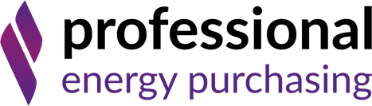

Notes to editors

About Professional Energy Purchasing
Professional Energy Purchasing is an award-winning independent energy consultancy who support commercial businesses with their energy needs. This Yorkshire-based team work with all major UK utility companies to leverage the best prices at the right time in the energy market for all business types. We offer a full energy management service including procurement, site installations and energy audits to help customers identify potential savings, to make energy buying easy, and to suggest renewable energy solutions to achieve the Government target of net zero emissions by 2050.

Contact: Georgina Campbell | 07932 389229 | 0114 327 2645 | info@pepgb.com

